1. A company makes two types of candles: fancy and classic. Fancy candles use up 8 ounces of wax and 16 ounces of glass and bring in a profit of $12 per candle. Classic candles use 4 ounces of wax and 4 ounces of glass and bring in a profit of $5 per candle. The company only has 320 ounces of wax and 480 ounces of glass to work with. How many of fancy and classic candles should be made to maximize profits?

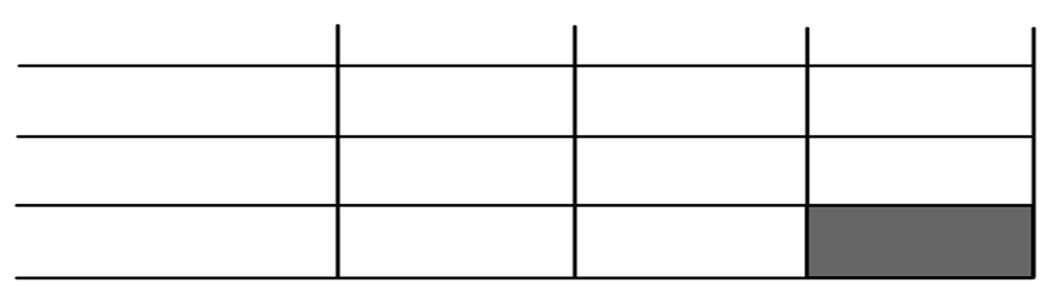

1. Define the variables.

_____________________________ ________________________________

1. Write the constraints.
2. __________________________________
3. __________________________________
4. __________________________________
5. __________________________________
6. Write the Objective Function.

___________________________________

1. Graph the constraints.
2. List two possible solutions and explain in words what

these solutions represent.

1. List the vertices.
2. Make a table to find the number of fancy and classic candles that will maximize profit.

Ordered Calculations Value

Pair

What is the maximum profit?

How many of each should they make?

1. A small company makes two types of car radios: the standard& the deluxe. Each standard requires 2 units of plastic to make and costs $2 for the electrical parts and brings in a profit of $14 each. Each deluxe requires 1 unit of plastic and costs $3 for the electrical equipment and brings in a profit of $24 each. The company has 200 units of plastic and has budgeted $360 for electrical parts. How many of the standard and deluxe should be made to maximize profit?



1. Define the variables.

_____________________________ ________________________________

1. Write the constraints.
2. __________________________________
3. __________________________________
4. __________________________________
5. __________________________________
6. Write the Objective Function.

___________________________________

1. Graph the constraints.
2. List two possible solutions and explain

in words what these solutions represent.

1. List the vertices.
2. Make a table to find the number of standard and deluxe radios that will maximize profit.

Ordered Calculations Value

Pair

What is the maximum profit?

How many of each should they make?